OceanGate Limited Project Documentation
Prepared by: [M.Talall farooq]
Institution: Aptech
Student id : student1655295
Project Name: OceanGate Limited Website
Overview: This project involves creating a responsive, modern website for OceanGate Limited, a data storage solutions provider. The website includes multiple pages such as Home, Products, Contact, About Us, and Where to Buy, with interactive sections, cards, and testimonials.

1. Home Page
- Features a fixed-top responsive navbar with the company logo and links to all pages.
- Hero section with heading, description, and buttons for 'Explore Products' and 'Learn More.'
- Card showcasing product types (HDDs, SSDs, Optical Media) with animated shadows.
- 'Why Choose OceanGate' section with 4 cards explaining key advantages.
- Product categories section showcasing Compact Disks, Storage Drives, Optical Drives, and Portable Storage.
- Stats banner showing company achievements.
- Customer testimonials with 3 example testimonials.
- Call-to-action section inviting users to browse products or get in touch.
- Footer with company info, quick links, support, and contact details.
Technologies Used: HTML, CSS, Bootstrap 5, Font Awesome.
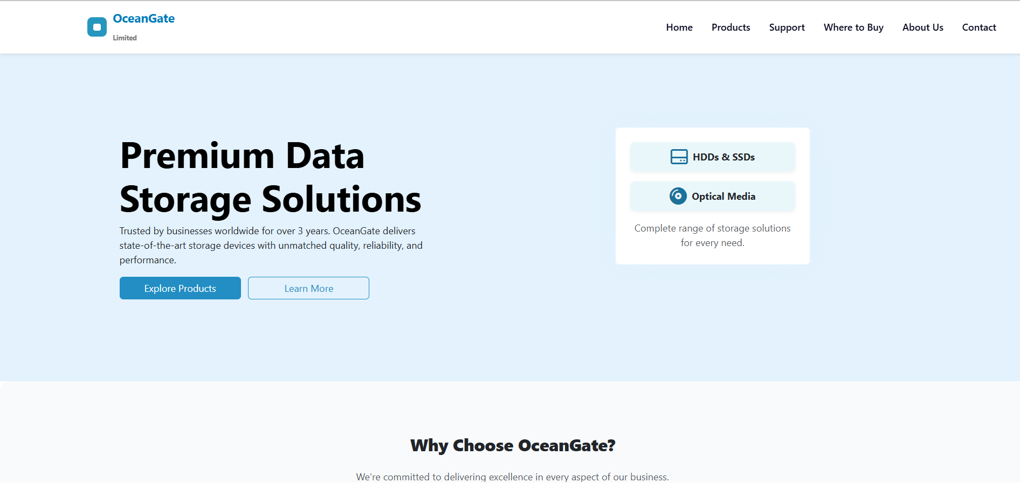

2. Products Page
- Lists all product categories with cards.
- Each card includes an icon, title, description, and link to view products.
- Hover effect on cards for interactive feel.
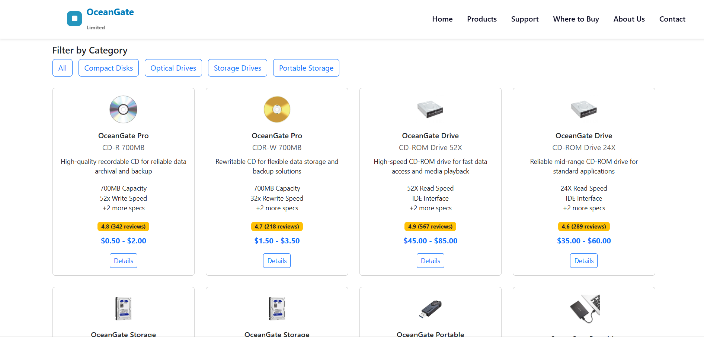

3. Contact Page
- Contact form with Name, Email, Subject, and Message fields.
- Map and company address included.
- Submit button styled with Bootstrap.
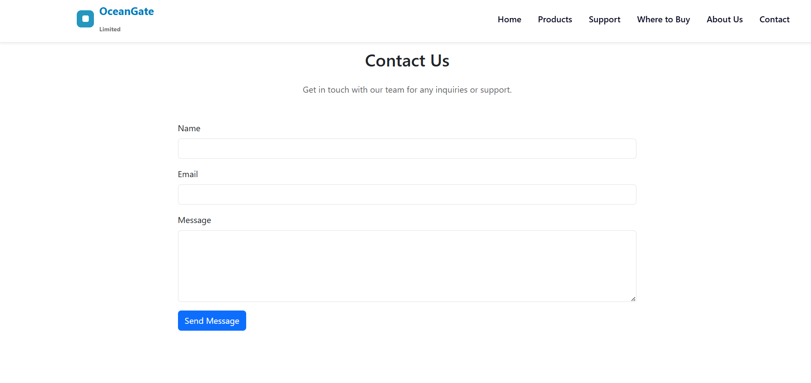

4. About Us Page
- Introduction to OceanGate Limited.
- Mission and Vision statements.
- Key achievements highlighted.
- Team members can be displayed.
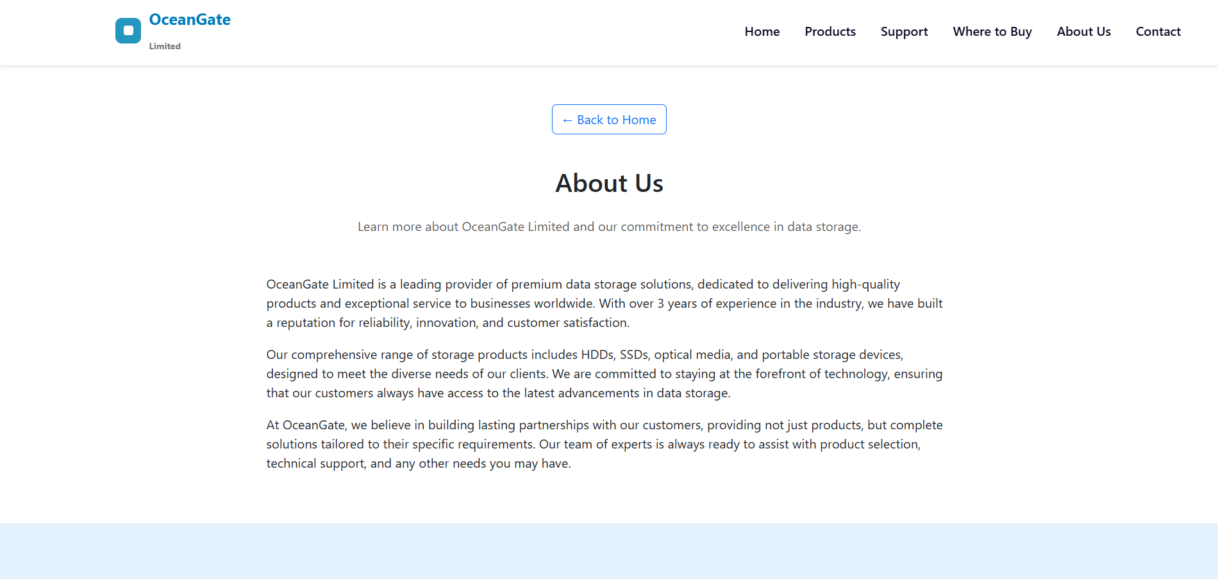

5. Where to Buy Page
- Lists authorized resellers or store locations.
- Interactive map to show store locations.
- Contact details for purchase inquiries.
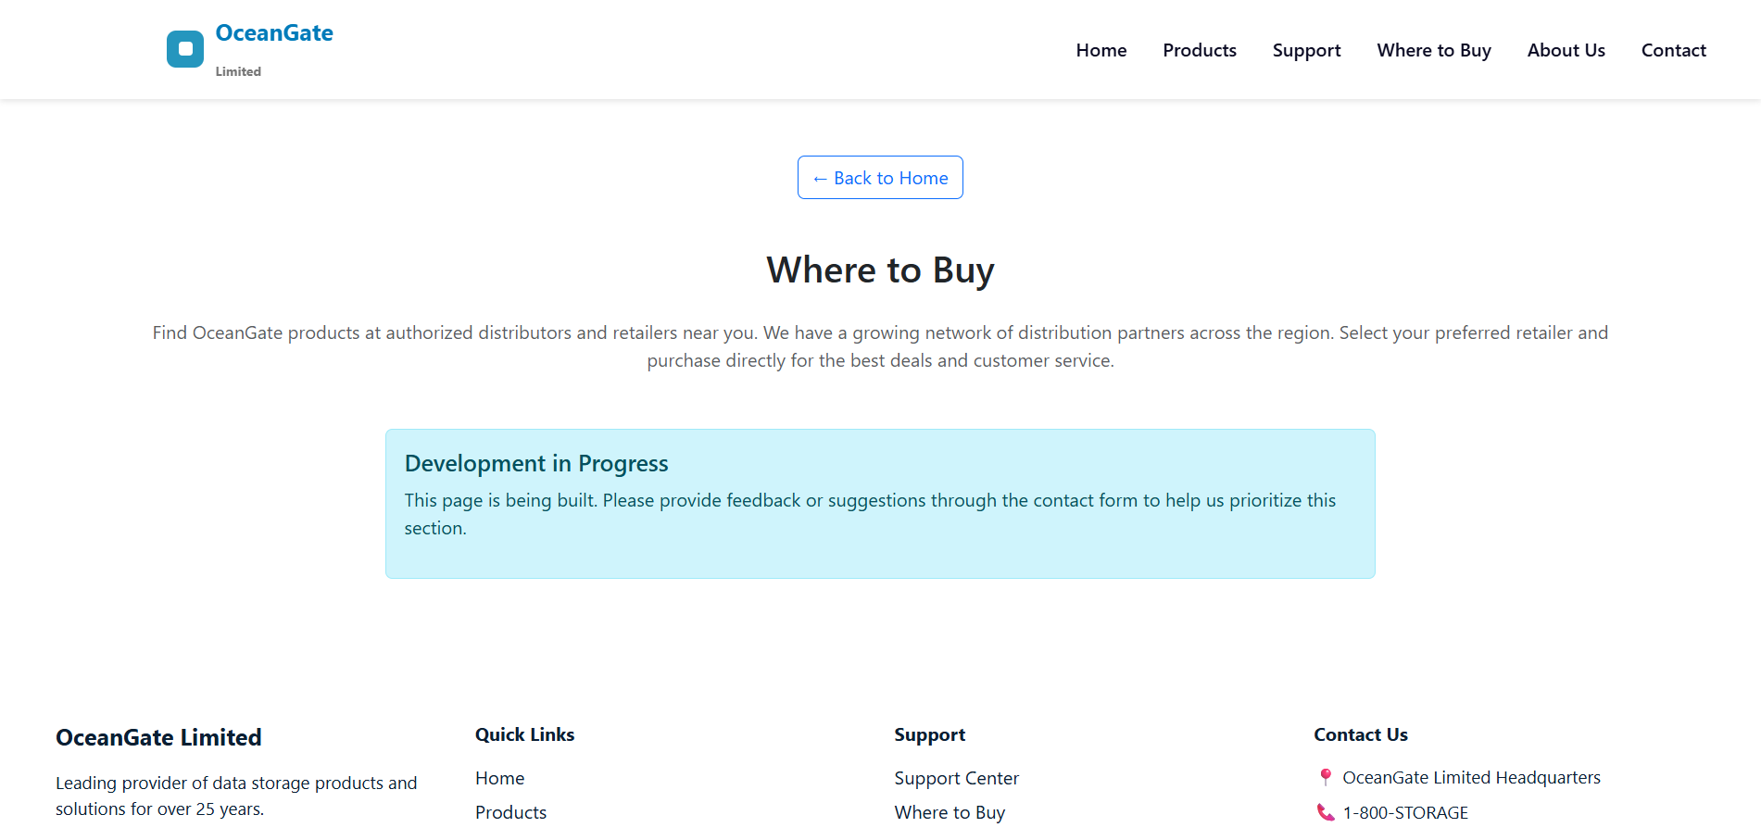

Project Creation Notes
- Navbar is responsive with collapse functionality for mobile.
- Hero section uses Bootstrap grid system for responsive layout.
- Cards designed with CSS for shadows, hover effects, and rounded corners.
- Testimonials section uses Bootstrap columns and custom styling.
- Stats banner uses gradient background and responsive design.
- Footer includes multiple columns for easy navigation.

Conclusion
This project demonstrates the creation of a modern, responsive website using HTML, CSS, and Bootstrap. All sections are interactive and optimized for user experience.

